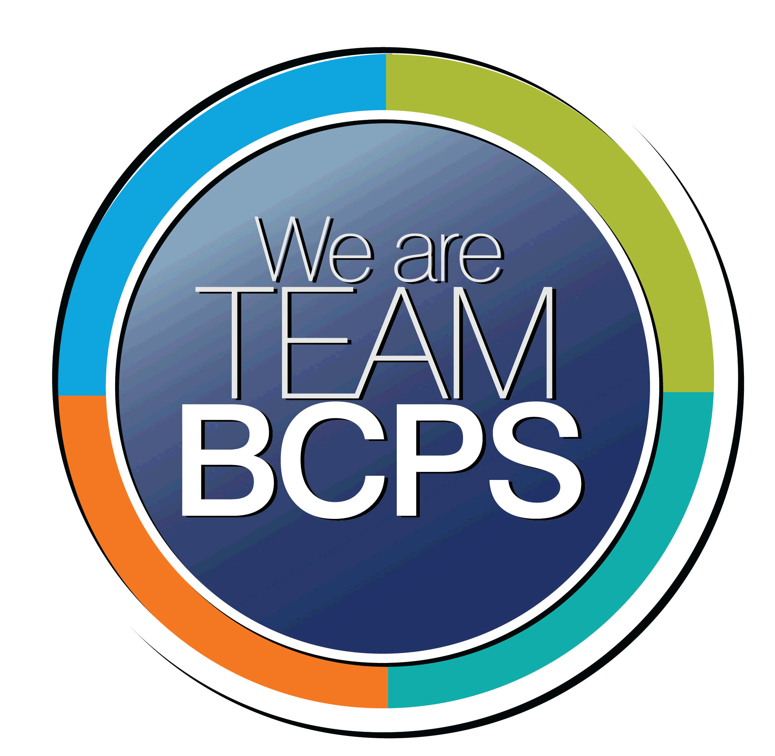 **Schoolwide Positive Behavior Plan** 

**Baltimore County Public Schools**

**Date Completed: 8/2/2022 School Year 2022-2023**

**School: Seven Oaks Elementary**

|  |
| --- |
| **Section 1: Initial Steps** |
|  |
| **School Climate Team** |
| *Identify members of a School Climate Team (consider a representative selection of members). The team meets initially to examine equity concerns and data and to develop the Schoolwide Positive Behavior Plan. The team should then meet monthly (minimum quarterly) to assess the effectiveness of the SWPBP on an ongoing basis.* |
| Climate Action Team: Bre Fortkamp, Robin Busick, Mandi Dean, Katie Flynn, Casey Pozanek, Danielle O’Ree, Lacy Rowan, Amanda Weber, Katie Astarita, Joy Casserly, Cristina Bernoni, Megan Ross, Gretchen Blackiston, Patricia Ivinski, Sam Karki, Jessica Leisenring, Rob Meloni, Mina Fried, Kim Anderson, Abby Gabrielse, Ginny Holbein, Yvonne Dungee |
| **Equity Lens** |
| *Through an equity lens, identify what the data indicate about the social-emotional needs of students and the support provided by staff members relative to disproportionality between student groups, especially for African Americans or students receiving special education. Also consider the school’s population with regard to ELL, Latinx, and/or other student groups. (Information may be from School Data Story)* |
| Seven Oaks is committed to implement equitable practices to support the development of staff and all students. This will be done by building relationships via open communication, and engagement with the goal of creating a welcoming and safe school where all are included.  At our school, the Kindergarten through Grade 5 2021-2022 September 30th enrollment indicates that we have 476 students, and our demographics are as follows:  31% Black/African American, 47% White, 9% Hispanic, 9% Two or More Races, 9% Asian.  The proportion of students eligible for receipt of special services are as follows: 2.5% English Learner, 28% Free and Reduced Meals, and 16% Special Education. The overall enrollment count has increased over the past 3 years.  During the same time period, the proportion of White students has decreased with Black and Hispanic/Latino increasing.  **Attendance/Chronic Absenteeism**  The 2021-2022 attendance rate was 93.08% (K-5) and 92.34% (PS- 5). 22% of the student population was chronically absent which was a significant increase from the previous year (fewer than 10%). Hispanic and Black subgroups had the highest percentage of chronically absent students; 31.58% and 29.13% respectively. Among special services, the chronic absenteeism rate for the students receiving special education services is 27.12%, which is an increase from the previous year at 23.33%. Among other special services, the rate for the FARMS student group is 37.5%, and the rate for the English Learner student group is 39.13%.  **Suspension**  The 2021-2022 suspension rate was 0.44% for females and 0.8% for males. One black female was suspended and 2 white males. SOES suspension rate was below the BCPS suspension rate. For the 2021-2022 school year, all student group suspensions resulted in the loss of 4 days of instruction. |
| **Data Analysis** |
| *Summarize what the data tell about the school climate. (Information from School Data Story)* |
| The Action Team will develop an adequate data collection process that will allow for relevant data analysis throughout the school year (i.e. data pertaining to who participates in the end of month celebration). Based on that data, changes may or may not be made to the PBP. In addition, the data will help the committee understand why a student engages in specific behaviors, identify the causes and then put in place interventions to bring about positive changes in the students’ s behavior. The data indicates that our student subgroup Black/African American lacks a sense of belonging and academic aspirations. The demographics of our student does not match the demographics of our school staff. The staff will be charged with unpacking that data piece and put supports, etc. in place to improve that data. |
| **Climate Goals** |
| *Identify the school’s goals in improving the social-emotional climate of the building. (Information from School Progress Plan)* |
| Educators will examine and interrogate their personal biases to become aware of the ways in which their own cultural experiences influence the conditions and learning opportunities that they create for students. Teachers will demonstrate cultural competency in making instructional decisions regarding the students they serve, including their strengths and needs. |
| **Section 2: Developing and Teaching Expectations** |
|  |
| **Expectations Defined** |
| *Identify a School Code of Conduct with 3-5 positively stated school expectations. Develop a way to communicate the identified rules, based on the schoolwide expectations, for specific settings within the school building. Expectations should be clearly stated, communicated, taught, and frequently referenced.* |
| SOES Code of Conduct: At Seven Oaks We Commit to be… respectful, responsible and safe. Our commitments are posted in the hallways and throughout the school. The commitments are also recited each morning during morning announcements. Expectations are reinforced by students earning hoots (class wide) and having the opportunity to attend monthly celebrations (individual). Posters throughout the building will provide examples of what respectful, responsible and safe looks like in different school environments such as the classroom, hallway, cafeteria, bathroom, playground, and bus. Videos of safe, responsible and respectful behavior were created by teacher leaders over the summer to share with students during the beginning of the school year. The videos will promote a discussion on what responsible, respectful and safe behaviors are vs are not. Classroom teachers will create a looks like/sounds like anchor chart for each commitment. Mini-lessons that align to our commitments will be shared with teachers during preservivce week to use during the beginning of the school year. The mini-lessons will help to share a consistent message throughout the building. |
| **Classroom Plan for Teaching and Reinforcing Expectations, Routines, and Procedures** |
| *Teachers develop visuals to communicate culturally relevant classroom expectations, routines, and procedures based upon the schoolwide expectations. Educators explicitly teach expectations, routines, and procedures. The school staff recognize and reinforce expected and positive behavior. Teachers identify encouraging procedures and corrective procedures for their classrooms.* |
| The teachers will teach, model and practice the SOES commitments using verbal and visual resources. This will be done at the beginning of the school year, during class meetings and reinforced throughout the day. A review will be conducted after winter and spring break. Staff will reinforce expectations by providing positive praise, hoots, etc. to generalize skills in multiple settings. Individual students demonstrating the SOES commitments are recognized by staff members and given positive office referrals. Those students are sent to the office where an administrator makes a positive phone call home and students sign their name on the Wall of Fame, which is located in the main hallway. |
| **Family/Community Engagement** |
| *Identify how the Schoolwide Positive Behavior Plan, the schoolwide expectations, and/or interventions will be communicated and shared with families. Consider how to include family and student voice in the initial plan and in evaluating the plan throughout the year.* |
| Staff will be introduced to the SOES PBP during preservice week and it will be revisited throughout the year by the Climate Action Team. Revisions, data, etc. will be shared with the faculty. The PBP will be shared with the school community so expectations are clear. The data collected and analyzed as well as the effectiveness of this program will be highlighted with the community. The PTA will also be involved as this program progresses. The Seven Oaks Commitments are outlined in the Parent Handbook that is distributed to families at the beginning of the school year. |
| **Section 3: Developing Interventions and Supporting Students** |
|  |
| **Resource Mapping of MTSS** |
| *Identify the evidence-based practices and interventions offered at Tier 1, Tier 2, and Tier 3 to support all students. Consider what culturally responsive interventions the school requires to meet the specific needs of the students.* |
| The multi-disciplinary team reviews the data, looks at problem solving interventions and progress monitors behaviors in order to create a positive school climate and address the needs of all children.  Tier 1- Teaching and reinforcing SOES Commitments. Tier1 practices and interventions: golden hoots, positive office referrals, individual class/home parent connection, Resource Staff Check In, Buddy Rooms, Problem Sub, Reflection Sheets, Conflict Resolution Strategies  Tier 2- Tier 1 practices and interventions in addition to consultation with staff/parents, referral to outside mental health provider or community partner, Check In/Check Out, Behavior Contracts/Charts, Zones of Regulation, breaks, Motor Room, Conflict Resolution Strategies (Note- some of the mentioned will only be used with identified Tier 2 students  Tier 3- Tier 1 and 2 practices and interventions in addition to referral to SST for possible FBA, individualized counseling services with counselor or psychologist, Check In/Check Out, creative schedule modifications, Motor Room, ensuring student has a BIP and if he/she does, it is appropriate and is implemented with fidelity, jobs/leadership opportunity, student contracts, personalized point sheets, referral to outside mental health provider or community partner, reflection/processing, parent contact and meetings with child, parents invited to school to sit with child, social skills instruction, Conflict Resolution strategies  Tier 1-3: awareness of cultural norms consulting with parents/guardians of cultural groups when considering interventions or consequences. |
| **Social-Emotional Learning** |
| *Identify the specific evidence-based social-emotional learning skill development practices the school will implement during the school year. Consider the importance of trauma-informed care, mental health awareness, level of students’ coping skills, etc. Determine how the social-emotional learning and the SEL competencies will be integrated into the school’s programming. Consider the need for any training the staff members may require.* |
| Seven Oaks is committed to social-emotional learning. The staff will continue their study of Conscious Discipline and continue implementing Conscious Discipline strategies to help students learn to regulate emotions. All teachers will have a safe space in the classroom and will provide instruction to students on how to utilize the safe space. During daily class meetings, teachers will implement brain smart start activities and Wish You Well. All students will choose how to be greeted by the teacher as they enter the classroom and all students will be assigned classroom jobs to establish a sense of belonging. The staff will unpack and discuss how social-emotional competency enhances the child’s ability to integrate their skills, attitudes and behaviors to deal with the challenges of daily life. Seven Oaks teachers will incorporate to their curriculum by promoting several learning strategies into their classroom. Ongoing training for the staff will be planned and implemented; possible ideas: more training of student support strategies, equity practices, CD refresher |
| **Character Education** |
| *Determine how specific evidence-based character education learning will be infused into the school’s programming to promote positive behavior and ethical decision-making. Character education will be culturally responsive and co-created with diverse stakeholders. Consider the need for any training the staff members may require.* |
| Seven Oaks emphasizes character education within their curriculum throughout the school day. The faculty and staff will teach and model to the students, core values of respect, citizenship, personal and community responsibility and safety. Each month the school focuses on a different value. The school counselor provides teachers with resources for each value that teachers introduce during class meetings and reinforce throughout the month. The virtue is shared on the WSOS student morning announcements and reinforced throughout the month. |
| **Professional Development for Staff** |
| *Identify the professional development that will be offered to staff members throughout the year in order to support their knowledge, skill development, and implementation of the interventions selected, the character education learning, and social-emotional learning practices. Specify the schedule for professional development and how to obtain teacher feedback during the year to address their concerns and areas in which they want/need more information. (Information from School Progress Plan.)* |
| The Climate Action Team will present an overview of the SOES school wide behavioral plan as well as be a resource for the teachers throughout the school year. The Action Team will model for the teachers how to implement the plan and collect the data, develop a behavioral management hierarchy, learn how to refer students for more intense interventions and incorporate SEL instruction into the classroom. In addition, the needs of the teachers will be addressed through ongoing professional learning training. |
| **Section 4: Supporting and Responding to Student Behavior** |
|  |
| **Recognitions/Incentives** |
| *Identify a variety of positive consequences, acknowledgements, recognitions, and/or incentives that are linked to the behavioral expectations and rules. Develop a system for implementing the positive acknowledgements consistently in school settings. Consider how to monitor who is being recognized and who is not being recognized and whether explicit or implicit biases may be occurring.* |
| The Climate Action Team has identified many classroom and school-wide incentives for students who demonstrate compliant behaviors that are consistent with the school’s Code of Conduct. These incentives include: class hoots for demonstrating school commitments and cafeteria hoots for demonstrating respectful, responsible and safe behaviors in the cafeteria. The class at each grade level with the most café hoots at the end of the month receives extra recess. Each time a class gets 25 hoots they receive a golden hoot and celebrate with a class party voted on by the students. Celebrations include: pajama day, lunch bunches with the teacher, picnic lunches, crazy hair day, bring a stuffed animal to school day etc. Students receiving 3’s and no more than one 2 for self-development on their report cards receive and Owl Award. Students demonstrating the commitments can receive positive office referrals and sign the Wall of Fame. |
| **Hierarchy for Behavioral Referrals and Consequences** |
| *Identify the behaviors that are teacher-managed, behaviors referred to resource staff, and behaviors referred to administration. Refer to the BCPS Student Handbook for teacher and administrator-led interventions. Consider how unsafe behaviors will be addressed.* |
| SOES teachers will address minor classroom behaviors while more intense behaviors will be referred to the administration. SOES teachers will be consistent regarding how they will respond and document classroom behaviors. The teachers will implement consistency with their response by following a hierarchical flow chart, which was created with teacher leaders during the summer of 2022. |
| **Response for Intensive Behaviors** |
| *Identify a hierarchy of responses to intensive behaviors (i.e., emergency/crisis management/threat assessment/unsafe behaviors) including interventions and supports. Indicate which school staff members will respond as well as procedures and training as needed.* |
| SOES has a hierarchy of response for more severe behaviors in place. They have identified who in the building will respond to the student when needed. This includes a team that responds to crisis situations and threat assessments. These staff members include (but are not limited to), the administration, the school counselor, school psychologist, special educator, the nurse, the parent and the teacher. If necessary, the Mobile Crisis Team may be called as an intervention to de-escalate the situation. Other resources within the community may be utilized such as the Handle with Care program with BCoPD. |
| **Monitoring the Schoolwide Positive Behavior Plan/Data Analysis** |
| *Identify the data that will be collected and reviewed by the School Climate Team in order to identify behavior trends, patterns, action steps, and interventions using a problem-solving strategy. Consider having a uniform referral form for staff to complete to document referrals to administration. Consider how teachers should document classroom-managed concerns/behaviors/difficulties. (Information from School Progress Plan.)* |
| The Climate Action Team will identify and collect and analyze the data monthly, which will assist the team in the decision- making process. The Climate Action Team will review the behavior trends and if needed make appropriate suggestions and modifications that will address the problems identified. The team will focus on any inequities that may occur. The Climate Team will share the successes noted as well as the areas that need improvement with the staff. The school has a referral form that is completed by the teacher when students are sent to the administration and that data is entered into Focus. |
| **Section 5: Miscellaneous Content/Components** |
|  |